

Project Name: Unlocking the Secrets of Microbially Influenced Corrosion: From Detection to Control Mechanisms

PI name: Assoc Prof Federico Lauro

Reported by Singapore Phenome Centre (SPC),
Lee Kong Chian School of Medicine,
Nanyang Technological University

Analyzed and prepared by: Abigail Thomson
Checked by: Prof Wang Yulan

NMR analysis
1. Method
Sample preparation (n=2)
500 µL of the bacterial culture and control media were aliquoted out into 2ml Eppendorf tubes each. 100 µL of PBS buffer containing 100% D₂0 was added and then vortexed for 30 seconds. The samples were then transferred to 5mm NMR tubes for analysis.

2) NMR analysis
Instrument: III HD 600 MHz Ascend NMR spectrometer (Bruker), with Shim system with high order shimming (BOSS III), 5mm BBI 600 MHz Z-Gradient high-resolution probe (Standard Probe), Sample Jet with cooling and preheating.
Solvent used: D20
Sample jet temperature: 5°C
Acquisition pulse sequence: 1d NOSEY
Probe temperature: 26.85°C (300 K)

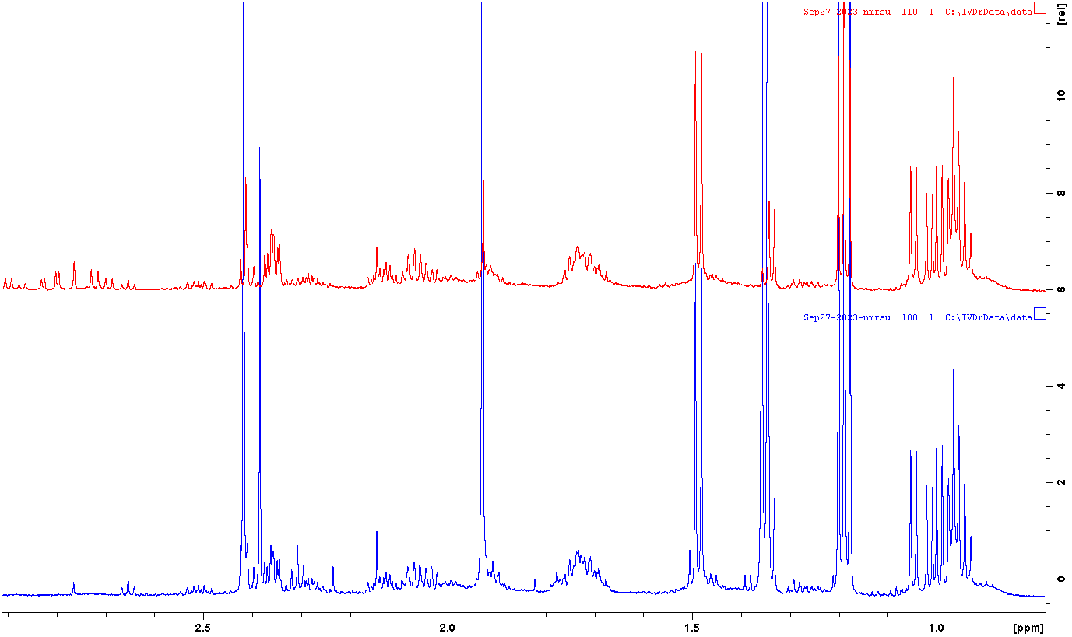
Experiment Results
Control
Figure 1: Bacterial Culture vs Control media spectra (from 0.6 ppm to 2.9 ppm)

Acetic
Acid

Bacterial Culture
Succinic
Acid
Acetic
Acid
Pyruvic
Acid
Lactic
Acid

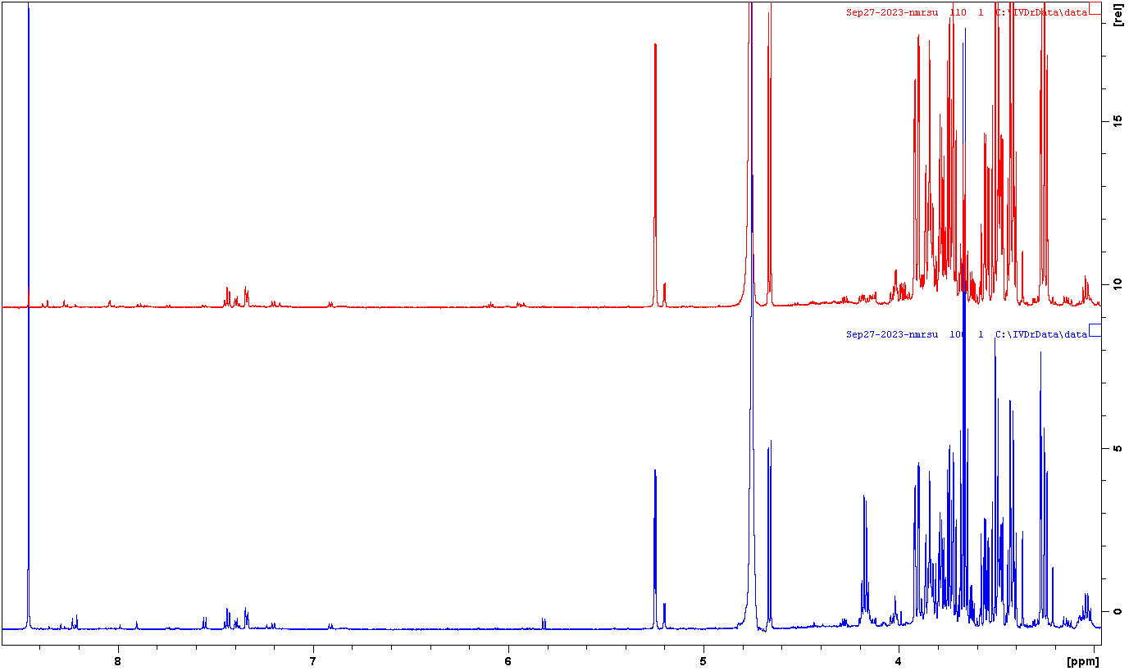
Lactic
Acid
Formic
Acid
Figure 2: Bacterial Culture vs Control Media spectra (from 3 ppm to 8.5 ppm)
Control

Bacterial Culture

Preliminary Conclusion

- Lactic Acid, Succinic acid, Pyruvic Acid and Formic acid are found in the bacterial culture sample and not in the control media sample.
- Acetic acid is found in both the bacterial culture and control samples.
- All peaks identified are putative and have not been confirmed by 2D NMR.

